Section 116 | EMPA Report No. | 168’349/706A

C O N F I D E N T I A L

Contract No. BRPR-CT96-0277 (DG 12 - RSMT)
BRITE EURAM BE96-3157
SIMCES
System Identification to Monitor Civil Engineering Structures

Task A1:
Bridge Tests
Progressive Damage Tests

Scenario: Settlement of Pier
No: 06

Measurement: 06

Type of Measurement: Ambient Test, 95 mm

Day: Tuesday 18.08.1998 / Wednesday 19.08.1998

Night Managers: Camiel A. M. de Smet CdS (EMPA) and
Christoph Krämer CHK (EMPA)

Helping Hands: HH 1: Magd Abdel Wahab (KUL),
HH 2: Albert Bral (KUL),
HH 3: Jeroen Deweer (LMS),
HH 4: Manfred Waldvogel MW (EMPA),

Comments to Measurement:
No comments

Acquisition Parameters
Number of Segments: 8
Number of Points/Segment: 8192
Sample Rate: 100 Hz

General Information
Filenames consist of the location, the signal was measured at plus the direction label. Direction Labels are set locally with
Girder locations:
L: Longitudinal, positive direction pointing to Koppigen
V: Vertical, positive direction pointing to zenith
T: Transversal, positive direction pointing to Bern
Example: 202T = location 202, transversal measurement

Koppigen Pier:
The sensors have been mounted in the plane of the pier, thus the measurement directions are skew relative to the girder.
L: Longitudinal, positive direction pointing to zenith
V: Vertical, positive direction pointing to Koppigen
T: Transversal, positive direction pointing to Zurich
Example: 531V = location 531, horizontal direction

Utzenstorf Pier:
The sensors have been mounted in the plane of the pier, thus the measurement directions are skew relative to the girder.
L: Longitudinal, positive direction pointing to zenith
V: Vertical, positive direction pointing to Utzenstorf
T: Transversal, positive direction pointing to Bern
Example: 421L = location 421, global vertical direction

Files (AAA Format):
Line No | Description | Example
1 | Label, also giving no. Of averages | 139V.aaa|8Averages
2 | Number of samples contained | 65536
3 | Sample interval in seconds | 0.01
4... | Samples | -2.904082e-03

Configuration:
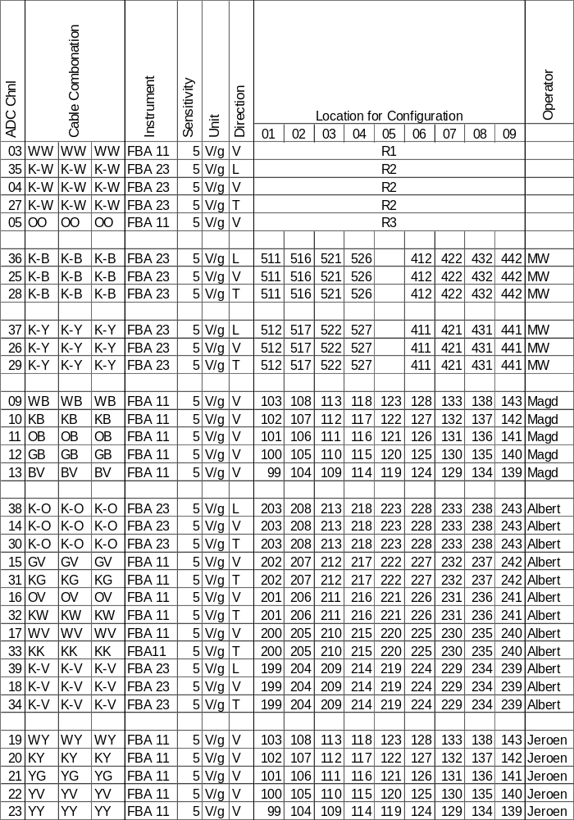

Sketches:
Girder, Top View
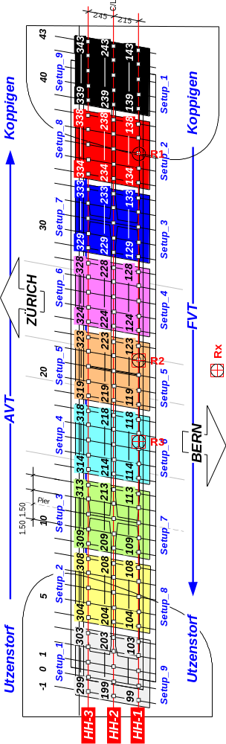
Koppigen Pier, Elevation
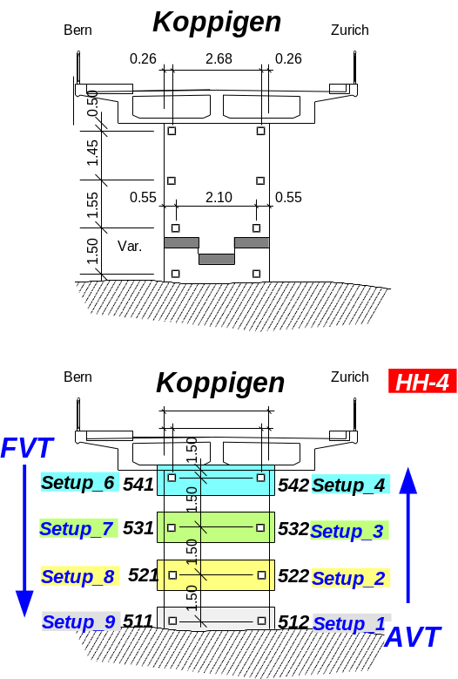

Utzenstorf Pier, Elevation
